Dimensionality Reduction Report
Global Life Expectancy Paradox
Week 7: Feature Selection, PCA and Variance Visualization

1. Executive Summary
The uploaded feature-engineered dataset contains 192 country records and 97 columns. To avoid redundant inputs from the earlier feature-engineering stage, this analysis returned to the 20 original cleaned columns. Fifteen original numeric indicators were evaluated as candidate predictors of average life expectancy. Univariate F-test feature selection retained the top 8 indicators. PCA on standardized predictors required 9 components to retain at least 90% of predictor variance (92.05% retained in the exported reduced representation). The final CSV contains 192 rows and 61 columns.

2. Problem Statement
The Global Life Expectancy Paradox asks why countries with differing socioeconomic, demographic, education, environmental and health indicators show substantial differences in life expectancy, and why income alone may not describe those differences. This report applies dimensionality-reduction methods to summarize the predictors and identify variables that are individually associated with average male/female life expectancy. The analysis is exploratory and does not establish causal relationships.

3. Data Preparation and Leakage Controls
- Records analysed: 192 countries; original cleaned feature set: 20 columns.
- Candidate predictor variables: 15 original numeric indicators.
- Target: average of life_expectancy_male and life_expectancy_female.
- Excluded from predictor inputs: male and female life expectancy (used to calculate the target), the target itself, the female–male gap, country names/codes, region labels, and all previously engineered *_scaled, *_minmax and *_log1p columns.
- StandardScaler was applied before PCA because the predictor variables use different units and ranges.
- Any missing numeric predictor values are median-imputed in the notebooks as a defensive step; the provided dataset's feature columns were used as supplied.

4. Feature Selection Method
SelectKBest with f_regression ranked each candidate predictor using a univariate linear-regression F-statistic against average life expectancy. The top eight features were marked in the final dataset. F-scores and p-values are supplied as a separate results CSV. Because the test evaluates features one at a time, the ranking does not measure each variable's unique contribution after adjusting for the others.

4.1 Feature-selection results
Rank | Feature | Correlation | Selected
1 | infant_mortality | -0.924 | Yes
2 | fertility | -0.839 | Yes
3 | internet_users | 0.801 | Yes
4 | secondary_school_enrollment_male | 0.771 | Yes
5 | secondary_school_enrollment_female | 0.771 | Yes
6 | urban_population | 0.568 | Yes
7 | gdp_per_capita | 0.492 | Yes
8 | homicide_rate | -0.159 | Yes
9 | co2_emissions | 0.120 | No
10 | unemployment | -0.102 | No
11 | sex_ratio | 0.101 | No
12 | gdp_growth | -0.082 | No
13 | pop_density | 0.071 | No
14 | forested_area | 0.024 | No
15 | population | 0.012 | No
The correlation sign indicates direction: positive values mean the indicator tends to increase alongside average life expectancy in this sample; negative values mean it tends to decrease. These are descriptive relationships.

5. Principal Component Analysis
PCA was applied to the 15 standardized predictor variables. Each principal component is a linear combination of the original indicators; the first component captures the largest possible variance, the second captures the largest remaining variance orthogonal to the first, and so on. PCA does not use the life-expectancy target to create components.
The smallest number of components that reached 90% cumulative explained variance was 9; the number needed to reach 95% was 11. The final dataset includes PC1 through PC9, retaining 92.05% of total standardized predictor variance.
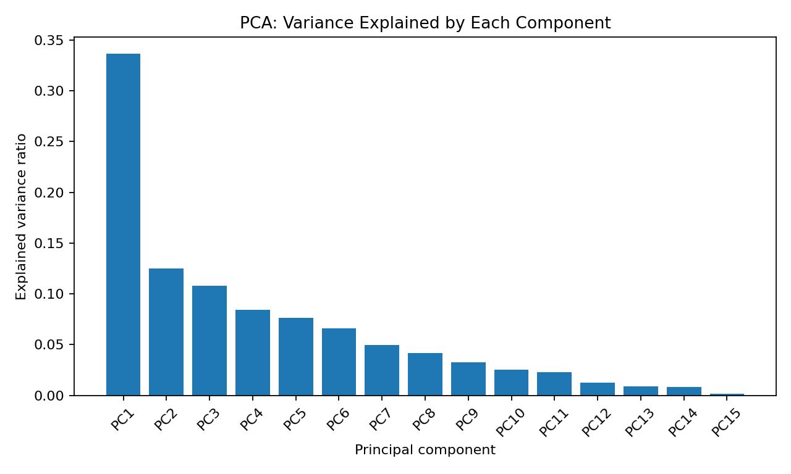
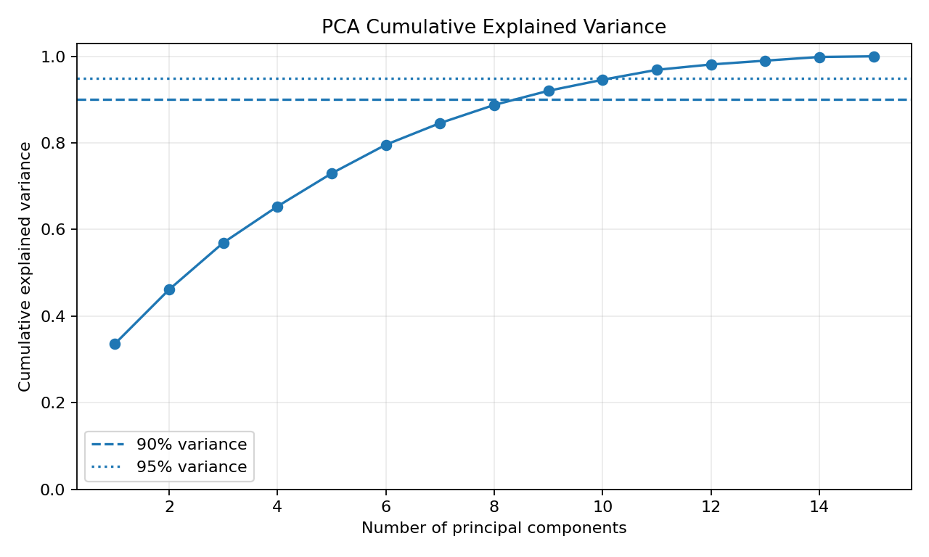

5.1 Explained variance table
Component | Variance explained | Cumulative variance
PC1 | 33.61% | 33.61%
PC2 | 12.53% | 46.14%
PC3 | 10.81% | 56.96%
PC4 | 8.40% | 65.36%
PC5 | 7.62% | 72.98%
PC6 | 6.61% | 79.59%
PC7 | 4.99% | 84.58%
PC8 | 4.19% | 88.77%
PC9 | 3.27% | 92.05%
PC10 | 2.54% | 94.59%
PC11 | 2.30% | 96.88%
PC12 | 1.23% | 98.12%
PC13 | 0.88% | 99.00%
PC14 | 0.85% | 99.85%
PC15 | 0.15% | 100.00%

6. Findings and Interpretation
The three highest-ranked indicators by univariate F-score are:
- infant_mortality: correlation = -0.924; F-score = 1102.90.
- fertility: correlation = -0.839; F-score = 451.72.
- internet_users: correlation = 0.801; F-score = 340.63.
The three lowest-ranked indicators by univariate F-score are:
- population: correlation = 0.012; F-score = 0.03.
- forested_area: correlation = 0.024; F-score = 0.11.
- pop_density: correlation = 0.071; F-score = 0.97.
These rankings describe individual linear associations in this sample. A feature with a lower univariate score may still be useful in combination with other variables, and correlated predictors may share similar information. PCA addresses shared variance by combining correlated features, but its components can be less interpretable than original variables.

7. Output Files
- global_life_expectancy_dimensionality_reduced.csv — original cleaned fields, target/gap, selected-feature flags, feature ranks and PCA scores.
- feature_selection_results.csv — F-scores, p-values, target correlations and selected status for all 15 candidate predictors.
- pca_explained_variance.csv — variance ratio and cumulative variance for every principal component.
- 01_Feature_Selection.ipynb — explanatory Markdown and executable feature-selection code.
- 02_PCA_and_Variance.ipynb — explanatory Markdown, PCA code and variance visualizations.
- 03_Final_Dimensionality_Reduction_Dataset.ipynb — combined workflow and final CSV export.

8. Limitations and Recommendations
- The data are country-level observations; associations do not establish causation and should not be used to infer individual-level outcomes.
- F-test feature selection is univariate and can be affected by outliers, nonlinearity and correlations among predictors.
- PCA maximizes predictor variance, not prediction accuracy or explanatory power for life expectancy.
- The data's measurement year and source comparability should be verified before substantive conclusions are drawn.
- For honest predictive evaluation, split into training and test sets first, then fit imputation, feature selection, scaling and PCA only on the training set.
- Inspect PCA loadings when explaining what each component represents; component scores alone do not reveal which original variables drive the component.

9. References
Scikit-learn, Feature selection user guide: https://scikit-learn.org/stable/modules/feature_selection.html
Scikit-learn, f_regression documentation: https://scikit-learn.org/stable/modules/generated/sklearn.feature_selection.f_regression.html
Scikit-learn, PCA documentation: https://scikit-learn.org/stable/modules/generated/sklearn.decomposition.PCA.html

